2026
Ghana Civil Aviation Authority (GCAA)


Document Number: <GCAA/RTI/2026> Subject to Revision by your institution
Government of Ghana

Right to Information Manual Template

Table of Contents
Table of Contents…………………………………………………………………………………..........i
1. Overview 1
2. Directorates and Departments under < Ghana Civil Aviation Authority(GCAA)> 2
2.1 Description of Activities of each Directorate and Department 3
2.2 <insert name of institution>’s Organogram 1
2.3 AGENCIES UNDER <Ghana Civil Aviation Authority> (Where applicable) 1
2.4 Classes and Types of information 5
3. Processing and Decision on Application – S. 23 6
4. Amendment of Personal Record 7
4.1 How to apply for an Amendment 7
5. Fees and Charges for Access to Information 8
6. Appendix A: Standard RTI Request Form 9
7. Appendix B: Contact Details of <GCAA’s Information Unit 12
8. Appendix C: Acronyms 13
9. Appendix D: Glossary 14

Overview
This Right to Information (RTI) Manual is pursuant to the provisions of the recently passed Act, (Act 989) by Parliament and assented to by the President, John Dramani Mahama. The Act gives substance to the constitutional right to information provided under Article 21 (1) (f) of the Constitution, enabling citizens access to official information held by government institutions, and the qualifications and conditions under which the access may be obtained. In accordance with Section 80, the Act applies to information which came into existence before, or which will come into existence after the commencement of the Act.

1.1 Purpose of Manual – To inform/assist the public on the organizational structure, responsibilities and activities of the Ghana Civil Aviation Authority (GCAA) and provide the types of information and classes of information available at GCAA, including the location and contact details of its information officers and units.
.

Directorates and Departments under Ghana Civil Aviation Authority (GCAA)
This section describes the institution’s vision and mission and lists the names of all Directorates and Departments under the institution, including the description of organizational structure, responsibilities, details of activities and classes and types of information accessible at a fee.
VISION
To become a World Class Aviation Regulator and Air Navigation Services Provider

MISSION
We regulate Civil Aviation and Provide Safe and Secure Air Navigation Services in a Professional and Environmentally Responsible Manner.
Directorates and Departments under <Ghana Civil Aviation Authority (GCAA)
1. Air Traffic Services
2. Air Traffic Safety and Engineering
3. Finance
4. Human Resources
5. Legal & International Relations
6. Safety Regulations
7. General Services
8. Internal Audit
9. Corporate Planning
10. Economic Regulation & Business Development
Responsibilities of the Institution:
To provide air navigation services within the Accra Flight Information Region (FIR) in a professional and environmentally responsible manner.

2.1 Description of Activities of each Directorate and Department

Directorate/Department | Responsibilities/Activities
Air Traffic Services | Provides separation between aircrafts both in the air and on the ground. Expediates and maintains orderly flow of air traffic within the Accra Flight Information Region as well as provide search and rescue services and aeronautical information services.
Air Traffic Safety and Engineering | To carry out planning, installation, operation, maintenance and servicing of mission-critical, safety of life air navigation equipment and facilities scattered through the Accra FIR
Finance | Making financial resources available to meet the Authority’s obligations
Human Resources | Responsible for personnel, welfare and training which include employee & industrial relations, employee benefits, leave, training programs and allowances.
Legal & International Relations | Responsible for the formulation of legal strategy and policy for the Authority and the development of directives, instructions, and circulars to give effect to the provisions of Act 678 and ICAO requirements to enable effective performance of the Authority’s regulatory functions. Also provides legal advice/ preparation and reviews various legal documents.
Safety Regulation | Regulates the aviation service providers and oprators to ensure they comply with standards of ICAO, Ghana Civil Aviation Directives (GCAD) and other relevant publications issued by the Ghana Civil Aviation Authority for the assurance of safe and secure air transportation for the travelling public.
General Services | The department is responsible for the management of infrastructural development, provision of all ICT related issues, procurement policies, procedures, plans and processes as well as the Authority’s transport operations.
Internal Audit | Assists the Authority to accomplish its objectives by bringing a systematic, disciplined approach to evaluate and improve the effectiveness of risk management, and the governance process as well as ensure that resources are acquired economically, used efficiently and are adequately protected.
Corporate Planning | They are responsible for corporate strategy facilitation, formulation, budgeting and corporate performance monitoring and evaluation
Economic Regulation & Business Development | Responsible for the licensing of air transport, economic regulation of the aviation industry, promoting and protecting the rights of the consumers in the aviation industry and facilitation in Ghana.
Ghana Civil Aviation Training Academy | To provide world-class competency-based Aviation Training by dedicated and professional specialists

2.2 Ghana Civil Aviation Authority’s Organogram

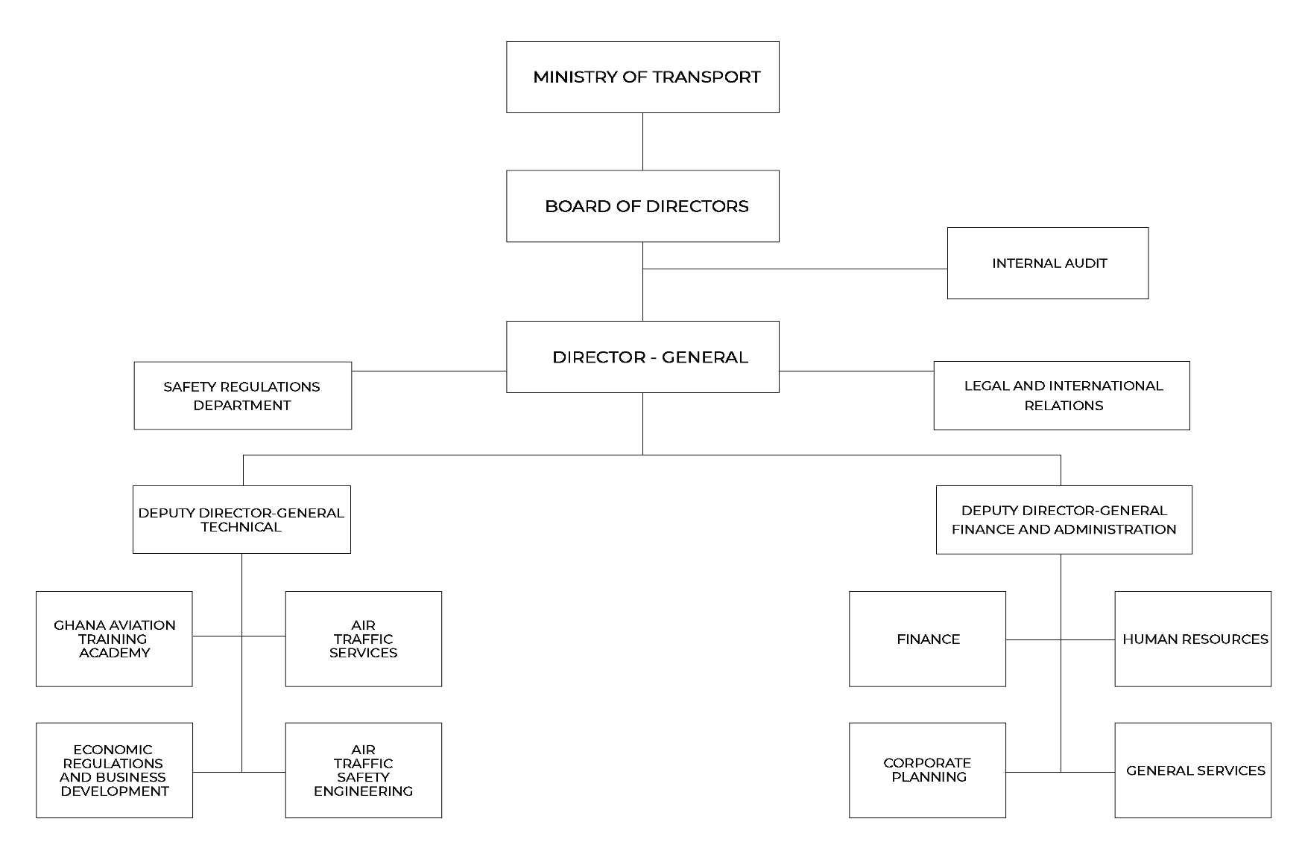

2.3 AGENCIES UNDER GHANA CIVIL AVIATION AUTHORITY
Agencies under Ghana Civil Aviation Authority
1.
2.
3.
4.
5.
6.
7. <Delete number if not applicable>
8. <Delete number if not applicable>
9. <Delete number if not applicable>
10. <Delete number if not applicable>

<insert name of first Agency listed at 2.3> (e.g NHI)
Responsibilities of the Agency: | Details of Activities:

<insert name of second Agency listed at 2.3>
Responsibilities of the Agency: | Details of Activities:  <click here and press enter for more space>

<insert name of third Agency listed at 2.3> (e.g NHI)
Responsibilities of the Agency: | Details of Activities:  <click here and press enter for more space>

<insert name of fourth Agency listed at 2.3> (e.g NHI)
Responsibilities of the Agency: | Details of Activities:  <click here and press enter for more space>

<insert name of fifth Agency listed at 2.3> (e.g NHI)
Responsibilities of the Agency: | Details of Activities:  <click here and press enter for more space>

<insert name of sixth Agency listed at 2.3> (e.g NHI)
Responsibilities of the Agency: | Details of Activities:  <click here and press enter for more space>

<insert name of seventh Agency listed at 2.3> (e.g NHI)
Responsibilities of the Agency: | Details of Activities:  <click here and press enter for more space>

<insert name of eight Agency listed at 2.3> (e.g NHI)
Responsibilities of the Agency: | Details of Activities:  <click here and press enter for more space>

<insert name of Ninth Agency listed at 2.3> (e.g NHI)
Responsibilities of the Agency: | Details of Activities:  <click here and press enter for more space>

<insert name of tenth Agency listed at 2.3> (e.g NHI)
Responsibilities of the Agency: | Details of Activities:  <click here and press enter for more space>
<To add more agencies, copy and paste the table>

2.4 Classes and Types of information

List of various classes of information in the custody of the institution:
- Information on Ghana’s Flight Information Region
- Landing permit charges.
- Information on airlines
- Overflight permit charges
- Information on Aeronautical Information Publication (AIP)
- Information on Notice to Airmen (NOTAM)
- Information on licensing and certification of aircrafts
- Information on RPA registration and operation
- Information on passenger rights
- Procedure in relation to flight delays
- Information relating to rights of persons with disabilities.
- Information on registration and deregistration of aircrafts

Types of Information Accessible at a fee:
- <List and Press enter for additional numbering>

Processing and Decision on Application – S. 23

1
2
3
Application made under s.18 is submitted to the Information Unit/ Registry of the Public Institution
The designated RTI Officer shall upon receipt of the application make a determination as to whether or not the application is one that safeguards the life or liberty of a person within the ambit of s. 23 (7)
4
5
6
Where the application does not fall within the ambit of s. 23 (7), the RTI Officer shall within 14 days of receiving the request, engage the relevant persons within the institution and the information generating directorate to confirm the availability of the information requested
Where an EXTENSION of time is needed, RTIO shall comply with S. 25.
IF NOT
Notice of the Decision shall be communicated to the Applicant by or on the 14th working day from when the application was made.
The Decision shall where it confirms the availability of information state the manner in which access will be granted and whether or not access to the information shall be given in part and the reasons for giving only part. (s. 23(1)(2)(3).
Where the information requested shall be refused, the RTIO shall notify the applicant within 12 days of receiving the application, communicating the refusal of the application and the reason for the refusal. Where it falls within the exempt category s.5-17; s.23 (10);s.24; the RTIO shall state the section/reason the refusal was based.

Amendment of Personal Record
A person given access to information contained in records of a public institution may apply for an amendment of the information if the information represents the personal records of that person and in the person’s opinion, the information is incorrect, misleading, incomplete or out of date.

4.1 How to apply for an Amendment
- The application should be in writing indicating;
- Name and proof of identity.
- Particulars that will enable the records of the public institution identify the applicant
- The incorrect, misleading, incomplete or the out of date information in the record.
- Signature of the applicant
- For incomplete information claimed or out of date records, the application should be accompanied with the relevant information which the applicant considers necessary to complete the records.

- The address to which a notice shall be sent should be indicated.

- The application can then be submitted at the office of the public institution

Fees and Charges for Access to Information

The Act mandates Parliament in Section 75 to approve a fee that public institutions can charge. However, fees shall apply to only the three circumstances stated below:
- Request for information in a language other than the language in which the information is held. (s.75) (3).

- When request is made for a written transcript of the information, a reasonable transcription cost may be requested by the Information Officer. (s.75) (4).

- Cost of media conversion or reformatting. (s.75) (5).
Under Section 75 (2), fees are not payable for:
- reproduction of personal information
- information in the public interest
- information that should be provided within stipulated time under the Act
- an applicant who is poor or has a disability
- time spent by the information officer in reviewing the information
- time spent by the information officer to examine and ensure the information is not exempt
- preparing the information

Section 76 subjects the retention of charges received by a public institution to the Constitution. Thus a public institution is authorized to retain charges received under the Act to be used only to defray expenses incurred by the public institution in the performance of functions under the Act and be paid into a bank account opened for the purpose with the approval of the Controller and Accountant-General.

Appendix A: Standard RTI Request Form
[Reference No.: ………………………….]

APPLICATION FOR ACCESS TO INFORMATION UNDER THE RIGHT TO INFORMATION ACT, 2019 (ACT 989)

 | Name of Applicant:
2. | Date:
3. | Public Institution:
4. | Date of Birth: |  | DD |  |  | MM |  | YYYY
5. | Type of Applicant: |  | Individual Organization/Institution
6. | TIN Number
7. | If Represented, Name of Representative:
7 (a). | Capacity of Representative:
8. | Type of Identification: National ID Card Passport Voter’s ID  Driver’s License
8 (a). | Id. No.:
9. | Description of the Information being sought (specify the type and class of information including cover dates. Kindly fill multiple applications for multiple requests):
10. | Manner of Access: |  |  | Inspection of Information  Copy of Information  Viewing / Listen  Written Transcript  Translated (specify language)
10 (a). | Form of Access: |  |  | Hard copy Electronic copy
11. | Contact Details: |  |  | Email Address__________________________________  Postal Address_________________________________  Tel: _________________________________________
12. | Applicant’s signature/thumbprint:
13. | Signature of Witness (where applicable)  “This request was read to the applicant in the language the applicant understands and the applicant appeared to have understood the content of the request.”

Appendix B: Contact Details of GCAA’s Information Unit

Name of Information/Designated Officer:
Nana Esi Noma Selby

Telephone/Mobile number of Information Unit:
0302776171
Email:
Postal Address of the institution:
Private Mail Bag, Kotoka International Airport, Accra, Ghana

Appendix C: Acronyms
Instructions: Provide a list of acronyms and associated literal translations used within the manual. List the acronyms in alphabetical order using the table below.
Table 1 Acronyms
Acronym | Literal Translation
RTI | Right to Information
MDA | Ministries, Departments and Agencies
s. | section
MMDAs | Metropolitan, Municipal and District Assemblies
ICAO | International Civil Aviation Organisation
GCAD | Ghana Civil Aviation Directives
RPA | Remotely Piloted Aircrafts

Appendix D: Glossary
This Glossary presents clear and concise definitions for terms used in this manual that may be unfamiliar to readers listed in alphabetical order. Definitions for terms are based on section 84 of the RTI Act.

Table 2 Glossary
Term | Definition
Access | Right to Information
Access to information | Right to obtain information from public institutions
Contact details | Information by which an applicant and an information officer may be contacted
Court | A court of competent jurisdiction
Designated officer | An officer designated for the purposes of the Act who perform similar role as the information officer
Exempt information | Information which falls within any of the exemptions specified in sections 5 to 16 of the Act
Function | Powers and duties
Government | Any authority by which the executive authority of the Republic of Ghana is duly exercised
Information | Information according to the Act includes recorded matter or material regardless of form or medium in the possession or under the control or custody of a public institution whether or not it was created by the public institution, and in the case of a private body, relates to the performance of a public function.
Information officer | The information officer of a public institution or the officer designated to whom an application is made
Public | Used throughout this document to refer to a person who requires and/or has acquired access to information.
Public institution | Includes a private institution or organization that receives public resources or provides a public function
Right to information | The right assigned to access information
Section | Different parts of the RTI Act

